APPLICATION FORMS
for additional services order

[Form 1] Company Information
[Form 2] Exhibitor Passes
[Form 3] Utilities
[Form 4] Application Form for Standard Booth and Other Services
[Form 5] Construction Subcontractor for the Space Only
[Form 6] Dangerous & Heavy Materials
[Form 7] Booth Event
[Enclosure] Furnitures & Fixtures Rental

[Form 1] Company Information

※ Submit the application form by E-mail (exhibition@iccv2019.kr) by September 20 (Fri.), 2019
1. This form will be used for the Exhibition Directory of the International Conference on Computer Vision 2019.
2. Briefly write the kind of products and services of your company.
3. Please be sure to enter correct spacing and upper and lower case letters.
4. Please send CI (Company Identity) in EPS format (Vector Images) with this document.

1. Application for Directory Publication

COMPANY INFORMATION
Booth No. |  | (Do not fill in the booth number)
Company Name*
Address  Information | Address*
Zip Code
(Postal Code)
 | Telephone* |  | Fax
 | Email* |  | Website
CONTACT INFORMATION
Name*
Job title
Telephone*
Company Description (Max. 1000 Characters)
2. Product Description
Please note that the image (jpg, png, etc.) should be high enough resolution to use. Images should be at least 300 dpi.

Product Description
(Image) | (Description)
(Product’s name)
(Image) | (Description)
(Product’s name)
(Image) | (Description)
(Product’s name)

3. Fascia
Company name will be shown in the 3m-long fascia.
Exhibitor/Company Name
(Please type exact name)

- This fascia is for Standard booth only.
- The name you applied with will be affixed to the top of the booth (Standard Booth) in English. If you not submit this form by September 20 (Fri.), your company name in the submitted application form will be used instead.
- The exhibitor logo or Company Identity (CI) is not included on the Basic Fascia (Logo print is optional).
- Write exactly, including spacing and punctuation.
- The fonts are unified in Gothic style and in English, they are written in upper case only.

[Form 2] Exhibitor Passes

※ Submit the application form by E-mail (exhibition@iccv2019.kr) by September 20 (Fri.), 2019
1. Exhibitor Pass is required in order to enter the ICCV 2019 Expo.
2. All companies participating in the ICCV 2019 Expo are requested to submit staffs’ information who will reside in the booth during the expo.
3. If exhibitors do not wear Exhibitor Pass, they cannot enter the Expo Hall. Please be accurate about the number of the residing staffs before applying for entry passes.
4. ICCV 2019 Expo will offer one (1) exhibitor pass for each 9m² of booth space. Please note that you should pay extra for additional pass. ICCV 2019 Expo will offer one (1) exhibitor pass for each 9m2 of booth space. Please note that you should pay extra for additional pass.
5. Expo Secretariat will give special codes that lets additional staffs register at KRW 400,000.

Entry Passes List |  | ※ Fill in exhibitor’s information
NO. | Name | Department | Job Title
Exhibitor
1
2
3
4
5
6
7
8
9

※ Additional Exhibitor Pass(Badges) Information
- Booth space includes one (1) exhibitor pass for each 9m² of booth space.
- Additional exhibitor passes may be purchased with the code which is provided to exhibitors at the ICCV 2019’s Official Website soon.
- Additional exhibitor pass: KRW 400,000 per person
- Please note that additional exhibitor passes cannot be purchased at onsite if we get max capacity.
[Form 3] Utilities

※ Submit the application form by E-mail (exhibition@iccv2019.kr) by September 20 (Fri.), 2019
1. This application is for additional Utilities like Electricity, Water Drainage, etc.
2. Both exhibitors for Standard Booth and Space Only will receive a basic 1kW/220V free of
charge.

1. Utility Services

Total Amount
Classification |  | Details |  | Prices
Electricity | Type | Price | Quantity
 | 220V/60Hz Single phase AC | KRW 60,000 / kW | kW | KRW
 | 220V/60Hz Three-phase current | KRW 60,000 / kW | kW | KRW
 | 380V/60Hz Three-phase current | KRW 60,000 / kW | kW | KRW
 | 24Hours/220V Three-phase current | KRW 70,000 / kW | kW | KRW
Water/Drainage(3kg/cm²) |  | KRW 250,000 / EA | EA | KRW
Compressed Air(7kg/m²) |  | KRW 250,000 / EA | EA | KRW
Internet Line(LAN) |  | KRW 150,000 / LAN | LAN | KRW
Subtotal |  | KRW
VAT (10%) |  | KRW
Total |  | KRW

- Please enter the correct quantity. If you need further inquiries about the utility, please contact to the Expo Secretariat.
- International calls will be charged separately (Standard rates will be applied).
- Water/Drainage does not include sinks.
- Wi-Fi is available inside the Expo Hall, but it may not work well depending on location and usage amount.
- The deadline for payment is September 20 (Fri.) and all contracts related to additional facilities will take effect after confirmation of payment has been made.
- 20% surcharge will occur to rent facilities onsite.

2. Location of Additional Facilities

※ Submit the application form by E-mail (exhibition@iccv2019.kr) by September 20 (Fri.), 2019
This form applies to exhibitors who apply for electricity, compressed air, water/drainage and telephone. Please mark preferred locations for installation and we will reflect your demands to set up your requested facilities. Please note that it is difficult to change the location after the set-up is completed.

<Example (1 square/0.5m)> <Display Area (1 square/0.5m)>

 | T | @

↑<Entrance of booth>

※ One square in the above figure is calculated as 1m². Please mark below items to desired location.

◆ | Electricity |  | T | Telephone
○ | 13-AMP Socket |  | □ | Water Supply facility
@ | LAN(Internet) |  | ■ | Drainage
 | 24Hours Electricity |  |  | Compressed Air
[Form 4] Application Form for Standard Booth and Other Services
(Paid Service)

※ Submit the application form by E-mail (exhibition@iccv2019.kr) by September 20 (Fri.), 2019
1. This form is prepared for Standard Booth exhibitors.
2. Please note that standard booth applicants MUST apply for standard booth so that build their booth. If not, ICCV 2019 Expo Secretariat offers the booth space only without any booth structure.
3. Space Only exhibitors also apply for standard booth, if desired.
4. Apart from 'Space Only' rental fee, setting up standard booth will be charged KRW 450,000.

1. Standard Booth (Available in different sizes)

Type | Unit Cost | Quantity | VAT (10%) | Total Price
1 booth  (3m x 3m=9m²) | KRW 450,000 EA | EA |  | KRW

Booth Rendering
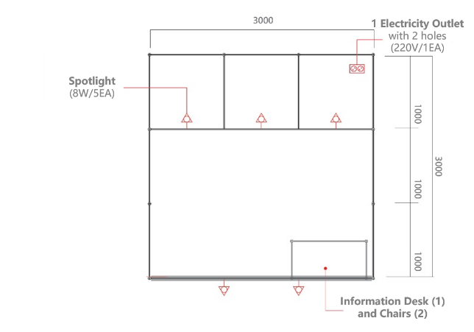

2. Printing Logo on the basic Fascia
- Apply for the logo which is approx. 20cm in size only.
- Please submit EPS format file (vector image) by e-mail.

Type | Unit Price | Quantity | Total Price
Fascia Logo | KRW 50,000 EA | EA | KRW

3. Signage Service Details
- ICCV 2019 Expo Secretariat offers finest signage service to exhibitors. Capabilities include four-color, photo-quality, high resolution digital printing virtually any size for banners, signage, exhibit graphics and more. Please refer to the following options:

Type |  | Materials | Unit Price | Quantity | Price
Signage  Service | A3 Sizes (29.7cm x 42cm) | Foam Board 5mm | KRW 30,000 | EA | KRW
 | A2 Sizes (42cm x 59.4cm) | Foam Board 5mm | KRW 50,000 | EA | KRW
 | A1 Sizes (59.4cm x 84.1cm) | Foam Board 5mm | KRW 70,000 | EA | KRW
 | X-Banner (60cm x 180cm) | Pet Banner  (including stands) | KRW 100,000 | EA | KRW
Printing  & Attaching | A Size (95cm x 238cm) | Banner  (including install & dismantling) | KRW 200,000 | EA | KRW
 | B Size (45.5cm x 238cm) | Banner  (including install & dismantling) | KRW 150,000 | EA | KRW
Sub-total |  |  |  |  | KRW
VAT (10%) |  |  |  |  | KRW
Total |  |  |  |  | KRW

Sample
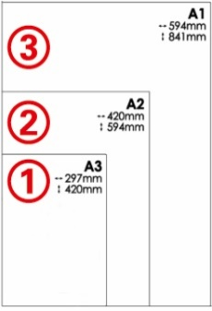 | 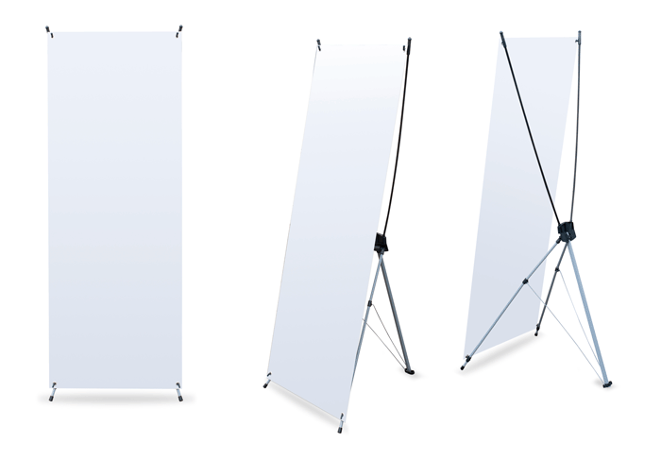
A1 / A2 / A3 | X-Banner | Booth Signage Service

[Form 5] Construction Subcontractor for the Space Only

※ Submit the application form by E-mail (exhibition@iccv2019.kr) by September 20 (Fri.), 2019
1. This is compulsory for Space Only Exhibitors.
2. Exhibitors should submit to the ICCV 2019 Expo Secretariat one copy of the floor plan elevation and booth design.
3. Space Only Exhibitors should contact to Expo Secretariat first before deciding booth constructing company. Exhibitors MUST choose official constructors as the constructing company to build their booths.
- All decorations, drapes, signs, banners, plastic displays, hay, straw, moss, split bamboo and other similar materials MUST BE FLAME RETARDANT to the satisfaction of the Fire Department and the Gangnam Fire Station.
- A Certificate of Flame Resistance shall be available for review by the Korea Fire Institute or on file with the Gangnam Fire Station for all decorative materials.

▶ Pre-submit booth design drawings and draft files
(Submitted to Expo Secretariat by September 20 (Fri.), 2019)
- Submit the floor plan elevation and booth design.
- The height limit of the unit is 6m from the floor.
- Booths should be installed 30cm from the wall of the exhibition hall. If walls and floor are damaged, the installer and the exhibitor must compensate for the damage.
- If your company is using retained equipment and structures in your company, you must notify Expo Secretariat first. Particularly, even if you have electric engineers, you must consult with the official electric contractor beforehand.
- Please refer to the Expo Manual for more information.

- Contact Information
 | ICCV 2019 Expo Secretariat
Email | exhibition@iccv2019.kr
Tel. | +82-2-6000-8189
FAX | +82-2-6000-8190

[Form 6] Dangerous & Heavy Materials

※ Submit the application form by E-mail (exhibition@iccv2019.kr) by September 20(Fri.), 2019
1. If you have plan to bring dangerous equipment and materials such as gas and oil into the Exhibition Hall, please fill out the following form.
2. It is also compulsory for exhibitors who bringing over-one-ton exhibits.
3. Please note that it may not be possible to bring dangerous equipment to the exhibition hall or needs any follow-up measures such as placement of safety guards.
4. Please note that exhibitors who do not notify their dangerous or heavy materials could be get disadvantages in the future according to the rules of Coex.

Dangerous goods Categories
The purpose of carrying in
Date of carrying-in |  |  |  |  | Date of move-out
No | Product Name |  | Unit | Amount | Container and packing | How to keep after carrying
1
2
3
4

Declaration of heavy materials
Equipment
Specification | Horizontal |  |  | mm |  |  | Vertical |  | mm | Height |  | mm
Weight |  |  |  | Ton
Weight Distribution Measures
Date
Amount |  |  |  |  | EA

- Forklift charges for freight loading are subject to prior consultation with the official carrier.
- Please plan in advance how to bring the exhibits to the exhibition hall because other companies will also bring heavy or bulky equipment.
- The weight distribution measures should be described in detail. In the case of any failure to weight distribution, the exhibitor shall bear all the liability.
[Form 7] Booth Event

※ Submit the application form by E-mail (exhibition@iccv2019.kr) by September 20 (Fri.), 2019
1. Exhibitors planning to any event are required to fill out this application form.
2. Companies wishing to hold an event inside the booth must notify the Expo Secretariat in advance.
3. The Exhibition is a place where all exhibitors introduce their own products. This requires all participating exhibitors to take extra care so as not to cause any damage to surrounding exhibitors.

Event Overview
Section | Detailed contents
Event Name
Date
Time
Content
Sound System /  Video System /  Others | (Describe specifications/quantity/main tools)

- Equipment, tools, and other items needed for an event have to be prepared by the exhibitors.
- The Expo Secretariat reserves the right to stop the event in the following cases:
- If the noise level is above 75dB
- If the event is held in the aisle or outside of the booth
- If neighboring exhibitors complain about the noise

As mentioned above, we will apply for the additional facilities
of the International Conference on Computer Vision 2019.

 |  | Date: | 2019. 00. 00

[Enclosures] Furnitures & Fixture Rental

※ Submit the application form by E-mail (exhibition@iccv2019.kr) by September 20 (Fri.), 2019
1. This is a complementary form for Furnitures & Fixture Rental.
2. The rental price covers the whole expo period.
3. Exhibitors can leave the furniture at the booth after Expo finished.
4. Please make sure to keep the application deadline because it is difficult to secure a supply just before the expo.

Furniture Rental Application |  |  | ※ Please refer to the furniture catalogue
No | Code No. | Item  (Name & Type) |  | Unit Price(\) | Quantity | Price(\) | Note  (Color etc.)
1
2
3
4
5
Sub Total
VAT(10% of Sub Total)
Total Amount (Sub Total+VAT)

- The price of items in the furniture & fixtures catalog will cover the expo period (5 days) and VAT (10%) could occur.
- In the event of damage or loss, 70% of the purchase price must be reimbursed.
- There may be quantity restrictions and price could change onsite.
- 20% of surcharge will occur for on-site furnishings & fixtures rental.
- The deadline for payment is September 20 (Fri.), 2019, and all contracts related to additional facilities will take effect after confirming that the payment has been made.

